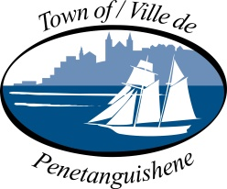

2020 BUDGET PUBLIC CONSULTATION

The Town of Penetanguishene is committed to ensuring our Budget development process engages residents and provides opportunities for input.

The Town will be holding our 2020 Budget Public Consultation in Council Chambers on:

Wednesday October 30, 2019 from 6:00 – 7:15 pm

We encourage residents to take this opportunity to share their thoughts, ideas and priorities on important financial issues and look forward to hearing feedback from our community.

Carrie Robillard, CPA, CGA
Director of Finance/Treasurer
705-549-7453 x210
crobillard@penetanguishene.ca
www.penetanguishene.ca

